**IP Addressing and Address Division**

Student Version



Huawei Technologies Co., Ltd.

|  |
| --- |
| **Copyright © Huawei Technologies Co., Ltd. 2020. All rights reserved.**  No part of this document may be reproduced or transmitted in any form or by any means without prior written consent of Huawei Technologies Co., Ltd.  **Trademarks and Permissions**  HW_POS_RBG_Vertical-150ppi.png and other Huawei trademarks are trademarks of Huawei Technologies Co., Ltd.  All other trademarks and trade names mentioned in this document are the property of their respective holders.  **Notice**  The purchased products, services and features are stipulated by the contract made between Huawei and the customer. All or part of the products, services and features described in this document may not be within the purchase scope or the usage scope. Unless otherwise specified in the contract, all statements, information, and recommendations in this document are provided "AS IS" without warranties, guarantees or representations of any kind, either express or implied.  The information in this document is subject to change without notice. Every effort has been made in the preparation of this document to ensure accuracy of the contents, but all statements, information, and recommendations in this document do not constitute a warranty of any kind, express or implied. |

|  |  |
| --- | --- |
| Huawei Technologies Co., Ltd. | |
| Address: | Huawei Industrial Base  Bantian, Longgang  Shenzhen 518129  People's Republic of China |
| Website: | <https://e.huawei.com/> |

**Huawei Certification System**

Huawei Certification follows the "platform + ecosystem" development strategy, which is a new collaborative architecture of ICT infrastructure based on "Cloud-Pipe-Terminal". Huawei has set up a complete certification system consisting of three categories: ICT infrastructure certification, platform and service certification, and ICT vertical certification. It is the only certification system that covers all ICT technical fields in the industry. Huawei offers three levels of certification: Huawei Certified ICT Associate (HCIA), Huawei Certified ICT Professional (HCIP), and Huawei Certified ICT Expert (HCIE). Huawei Certification covers all ICT fields and adapts to the industry trend of ICT convergence. With its leading talent development system and certification standards, it is committed to fostering new ICT talent in the digital era, and building a sound ICT talent ecosystem.

Huawei Certified ICT Associate-Datacom (HCIA-Datacom) is designed for Huawei's frontline engineers and anyone who want to understand Huawei's datacom products and technologies. The HCIA-Datacom certification covers routing and switching principles, basic WLAN principles, network security basics, network management and O&M basics, SDN and programmability and automation basics.

The Huawei certification system introduces the industry, fosters innovation, and imparts cutting-edge datacom knowledge.

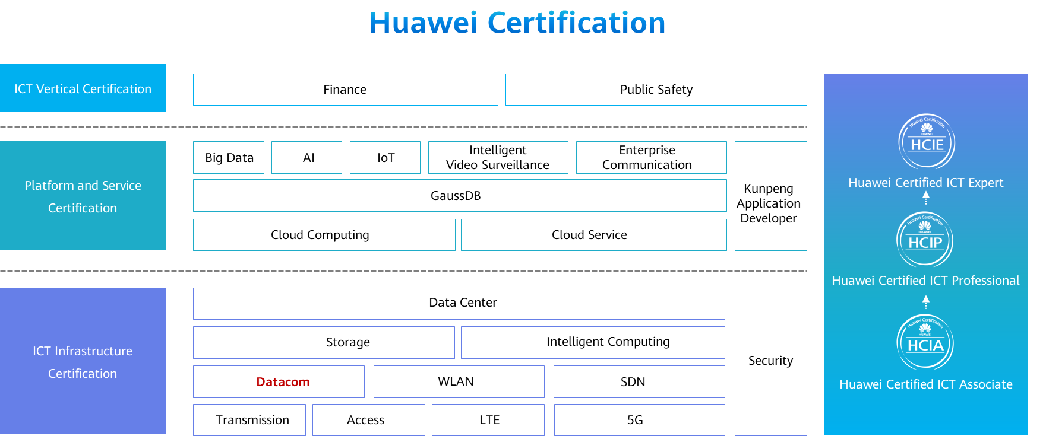

# IP Addressing and Address Division

## Background

IP addresses are fundamental for networks. IP address planning is crucial to network construction, and the continuity, scalability, structuring, and service correlation of IP addresses must be considered.

An enterprise department has two service teams: Group1 and Group2. Group1 has one employee and Group2 has three employees now, and will not exceed 5 and 12, respectively, in the future. The address segment 192.168.1.192/27 has been allocated to the department. Please plan IP addresses for the two service teams and allocate IP addresses to existing employees.

## Objectives

Upon completion of this exercise, you will be able to:

* Master the method of configuring IP addresses.
* Master the method of allocating IP addresses.

## Topology

Lab Topology

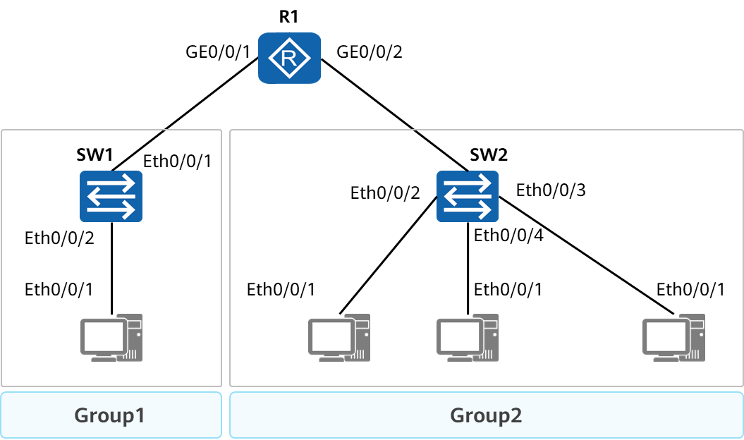

The IP address segment 192.168.1.192/27 allocated to the department has 30 available IP addresses.

* Group1 will have a maximum of five employees. A total of six IP addresses are required because one gateway address is required. Therefore, the IP address segment 192.168.1.192/29 can be planned for the team.
* Group2 wil have a maximum of 12 employees. A total of 13 IP addresses are required because one gateway address is required. To prevent conflicts with the IP address segment of Group1, the IP address segment 192.168.1.208/28 can be planned for the team.

## Implementation

### Roadmap

1. Configure the gateway IP addresses.
2. Configure the PC IP addresses.

### Procedure

Configure the gateway IP address.

Log in to the router (gateway) through the console port or other methods, enter the system view, and change the device name to R1.

Enter the interface view of GE0/0/1 and configure an IP address for the interface. (The IP address can be any host address on the network segment 192.168.1.192/29.)

Configure an IP address for GE0/0/2 in the same way as you configure an IP address for GE0/0/1. (The IP address of GE0/0/2 can be set to any host address on the network segment 192.168.1.208/28.)

Configure an IP address for PC1 in Group1.

Configure the IP address of PC1.Open **Control Panel**, choose **Network and Sharing Center** > **Change Adapter Settings**, right-click the network adapter whose IP address needs to be changed, and choose **Properties** from the shortcut menu. In the displayed dialog box, find **Internet Protocol Version (TCP/IPv4)**, click **Properties**, and configure the IP address.

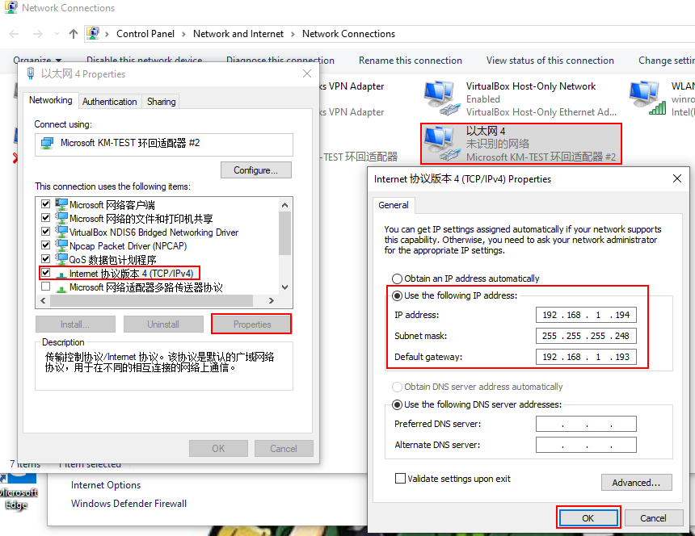

Configure the IP addresses of the PCs in Group2. The method is the same as that of configuring the IP address of PC1 in Group1.

----End

## Verification

Check the IP address of the router (gateway).

[R1]display ip interface brief

\*down: administratively down

!down: FIB overload down

^down: standby

(l): loopback

(s): spoofing

(d): Dampening Suppressed

The number of interface that is UP in Physical is 3

The number of interface that is DOWN in Physical is 8

The number of interface that is UP in Protocol is 3

The number of interface that is DOWN in Protocol is 8

Interface IP Address/Mask Physical Protocol

Ethernet0/0/0 unassigned down down

Ethernet0/0/1 unassigned down down

GigabitEthernet0/0/0 unassigned down down

GigabitEthernet0/0/1 192.168.1.193/29 up up

GigabitEthernet0/0/2 192.168.1.209/28 up up

GigabitEthernet0/0/3 unassigned down down

NULL0 unassigned up up(s)

Serial0/0/0 unassigned down down

Serial0/0/1 unassigned down down

Serial0/0/2 unassigned down down

Serial0/0/3 unassigned down down

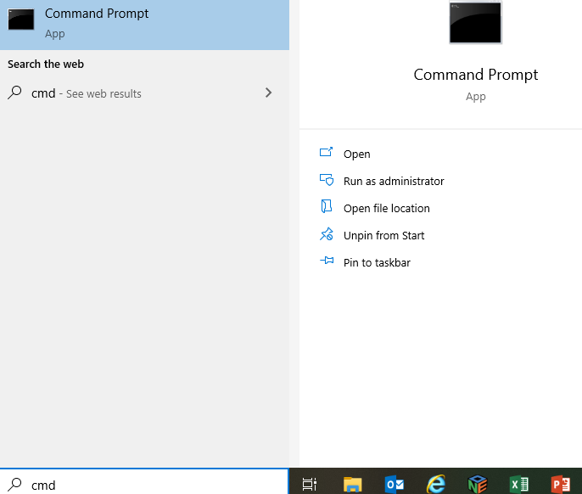

Check the IP address of the PC. Choose **Start** > **Run**, enter **cmd**, and press **Enter** to open the CLI. Run the **ipconfig** command.

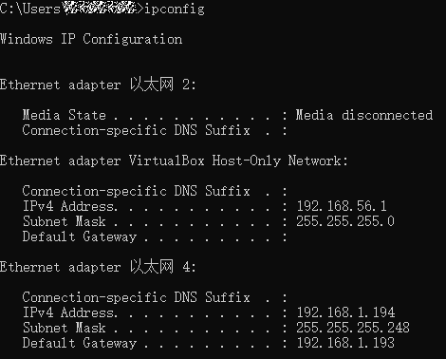

Ping the IP address of PC2 from PC1.

[C:\~]$ping 192.168.1.210

Ping 192.168.1.210: 32 data bytes, Press Ctrl\_C to break

From 192.168.1.194: Destination host unreachable

From 192.168.1.194: Destination host unreachable

From 192.168.1.194: Destination host unreachable

From 192.168.1.194: Destination host unreachable

From 192.168.1.194: Destination host unreachable

--- 192.168.1.193 ping statistics ---

5 packet(s) transmitted

0 packet(s) received

100.00% packet loss

PC1 and PC2 are on different network segments, and no routing protocol is configured. Therefore, PC1 fails to ping PC2.

Ping the IP address of PC3 from PC2.

[C:\~]$ping 192.168.1.211

Ping 192.168.1.211: 32 data bytes, Press Ctrl\_C to break

From 192.168.1.211: bytes=32 seq=1 ttl=255 time=31 ms

From 192.168.1.211: bytes=32 seq=2 ttl=255 time=16 ms

From 192.168.1.211: bytes=32 seq=3 ttl=255 time<1 ms

From 192.168.1.211: bytes=32 seq=4 ttl=255 time<1 ms

From 192.168.1.211: bytes=32 seq=5 ttl=255 time=32 ms

--- 192.168.1.194 ping statistics ---

5 packet(s) transmitted

5 packet(s) received

0.00% packet loss

round-trip min/avg/max = 0/15/32 ms

PC2 and PC3 are on the same network segment. Therefore, PC2 can ping PC3.